URINE DIAGNOSTICS / ANALYZER / URILYZER 500 PRO

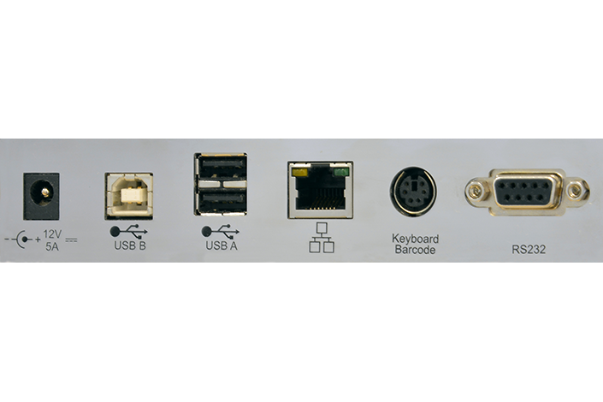
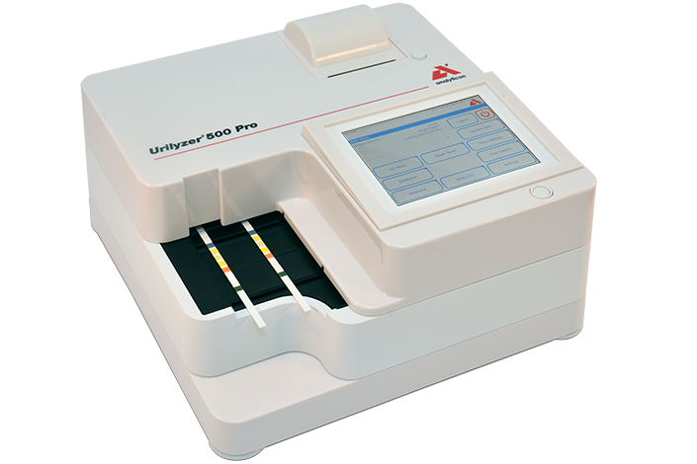
The Urilyzer® 500 Pro is a semi-automated urine test strip analyzer with continous loading function. The system is provided with state-of-the-art operator and QC management as well as enhanced connectivity capabilities to meet the growing demands for compliance management and data capture. Moreover, the system provides the user with a high level of customization with flexible testing and reporting options.

Features and Functions
- Easy to use
- Data Management
- Quality Control Management
- Operator Management

Technical Data
Type | Semi-automated urine test strip analyzer with continous loading
Measurement technology | Reflectance photometer with 4 discrete wavelengths 505, 530, 620, 660 nm
Parameters | Bilirubin, Urobilinogen, Ketones, Ascorbic Acid, Glucose, Protein (Albumin), Blood (Hemoglobin), pH, Nitrite, Leucocytes, Specific Gravity
Throughput | Up to 500 tests/hour
Data storage | Patient database: 5.000 tests / QC database: 5.000 tests
Display | 5.7” LCD VGA capacitive touchscreen
Interfaces | Serial RS232, USB Type A, USB Type B, PS2 (external keyboard, barcode reader), Ethernet
Dimensions | 300 x 300 x 180 mm (WxDxH)
Weight | 6.5 kg
Power supply | 12V DC/5A
Operating environment | Temperature: +15°C to +30°C
 | Relative humidity (non-condensing): 20% to 80 %
Printer | Built-in thermal printer
Barcode reader | External
Protocols | LIS2 (ASTM+), HL7

Accessories:
- CombiScreen® 11SYS PLUS
- CombiScreen® 11SYS
- Thermo printer paper 57 mm

